**Chapter 5.**

**2021. 04. 14.**

**Problem 5-51**

Draw examples of the following:

(a) A meso compound with the formula C8H18

(b) A meso compound with the formula C9H20

(c) A Compound with two chirality centers, one *R* and the other *S*

**Problem 5-54**

Ribose, an essential part of ribonucleic acid (RNA), has the following structure:

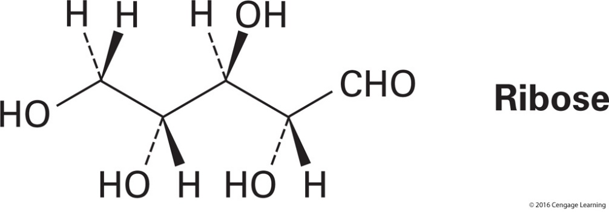

(a) How many chirality centers does ribose have? Identify them.

(b) How many stereoisomers of ribose are there?

(c) Draw the structure of the enantiomer of ribose.

(d) Draw the structure of a diastereomers of ribose.